# Simple FSM Diagram

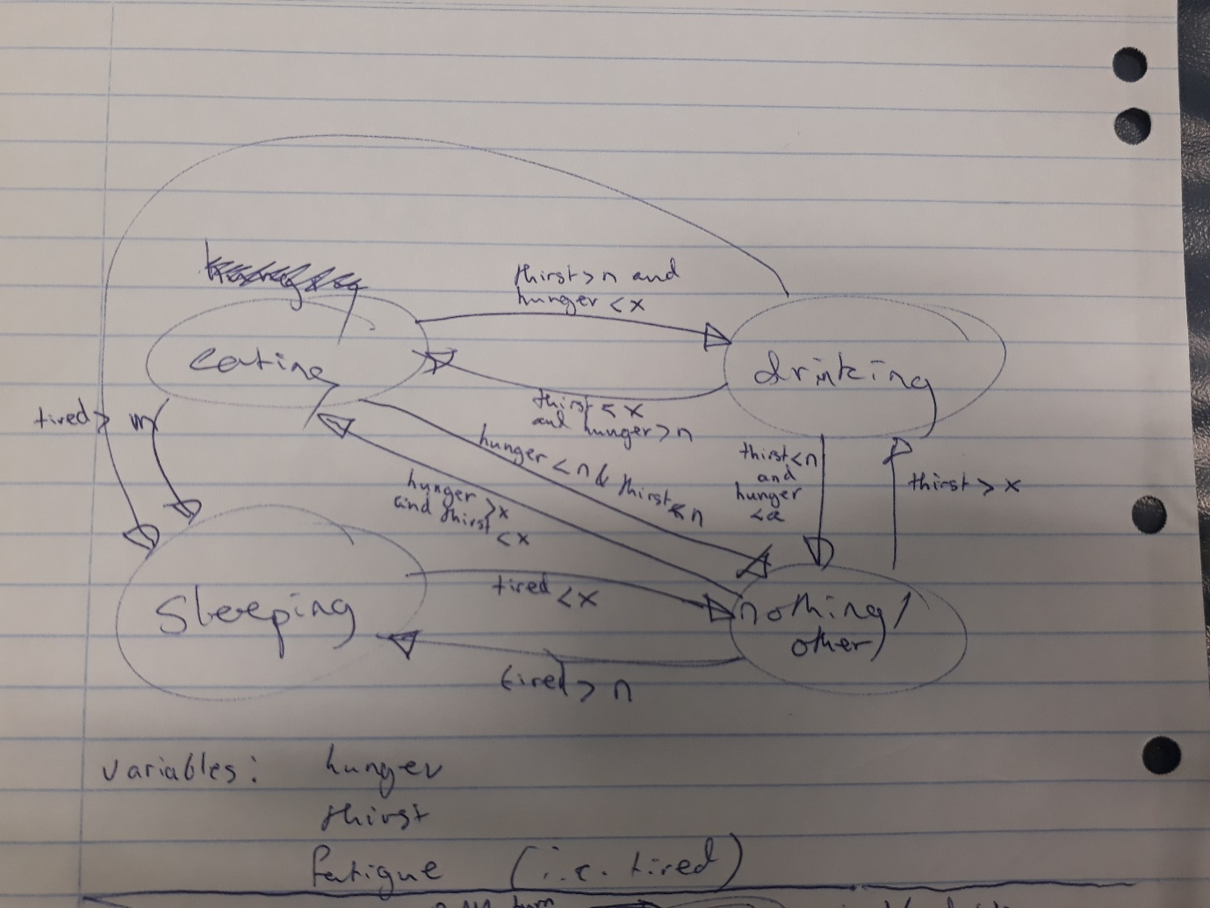

# Simple FSM Code

class SimpleFSM:

def Thinking(self):

#local variables

fatigue = 0

hunger = 0

thirst = 0

states = ["eating", "drinking", "sleeping", "awake"]

currentState = "awake"

alive = True

running = True

maxLimit = 100

gameTime = 0

while running and alive:

gameTime += 1

#sleeping: reduce fatigue, everything else increases

if currentState is "sleeping":

#sleep

print("Zzzzzzzzzzz")

fatigue -= 1

hunger += 0.5

thirst += 0.5

#check if not tired

if fatigue < 5:

#check for other states

if thirst > 7:

currentState = "drinking"

elif hunger > 7:

currentState = "eating"

else:

currentState = "awake"

#awake: doing nothing, all variables increase

elif currentState is "awake":

#do nothing

print("Bored . . .")

hunger += 1

thirst += 1

fatigue += 1

#check for other states

if fatigue > 15:

currentState = "sleeping"

elif thirst > 7:

currentState = "drinking"

elif hunger > 7:

currentState = "eating"

#eating: hunger reduces, fatigue and thirst increase

elif currentState is "eating":

#eat

print("Om nom nom nom")

hunger -= 2

thirst += 1

fatigue += 0.5

#check for other states

if fatigue > 15:

currentState = "sleeping"

elif thirst > 7:

currentState = "drinking"

elif hunger < 2:

currentState = "awake"

#drinking: thirst reduces, all other states increase

elif currentState is "drinking":

#drink

print("Gulp gulp gulp")

thirst -= 2

hunger += 1

fatigue += 0.5

#check for other states

if fatigue > 15:

currentState = "sleeping"

elif thirst < 2:

if hunger > 7:

currentState = "eating"

else:

currentState = "awake"

else:

#broken

print("Why are you here? The code must have something wrong with it . . .")

die()

#checking if starved to death

if hunger > 20:

alive = False

print("Gurgle . . . Gurgle . . . *death rattle*")

elif thirst > 20:

alive = False

print("*gasp* . . . *gasp* . . . *death rattle*")

elif fatigue > 20:

alive = False

print("*thud* . . . *death rattle*")

#checking for end of game time

if gameTime > maxLimit:

running = False

print("*siren goes off*")

print("Hello world!")

ai = SimpleFSM()

ai.Thinking()

print("--- The End ---")